Silhouette metric for img015001.jpg is: 0.9247024088729734

Davies Bouldin metric for img015001.jpg is: 0.12613428922661424

Calinski Harabasz metric for img015001.jpg is: 173327.88067184226

ID 0: (1710, 681)

ID 1: (99, 368)

ID 2: (134, 606)

ID 3: (56, 721)

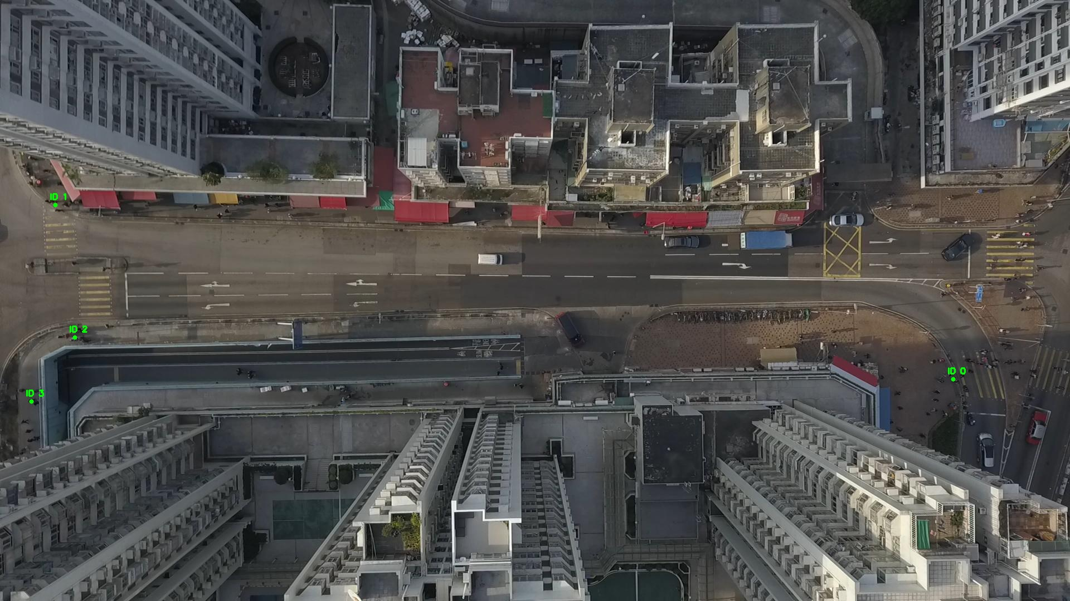

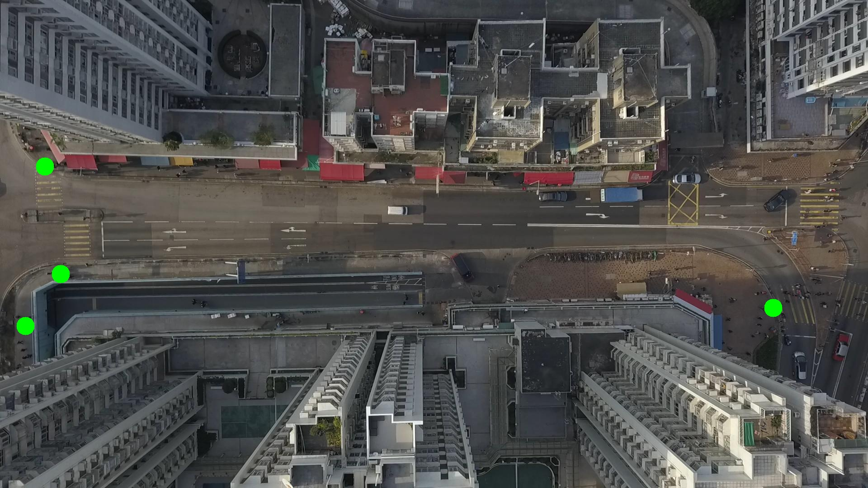

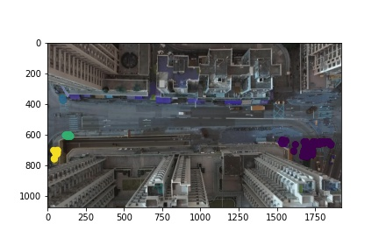

Silhouette metric for img015002.jpg is: 0.6872938801590478

Davies Bouldin metric for img015002.jpg is: 0.2431850248093524

Calinski Harabasz metric for img015002.jpg is: 331867.85017792205

ID 0: (1724, 683)

ID 1: (99, 368)

ID 2: (132, 606)

ID 3: (52, 741)

ID 4: (329, 1054)

ID 5: (1543, 648)

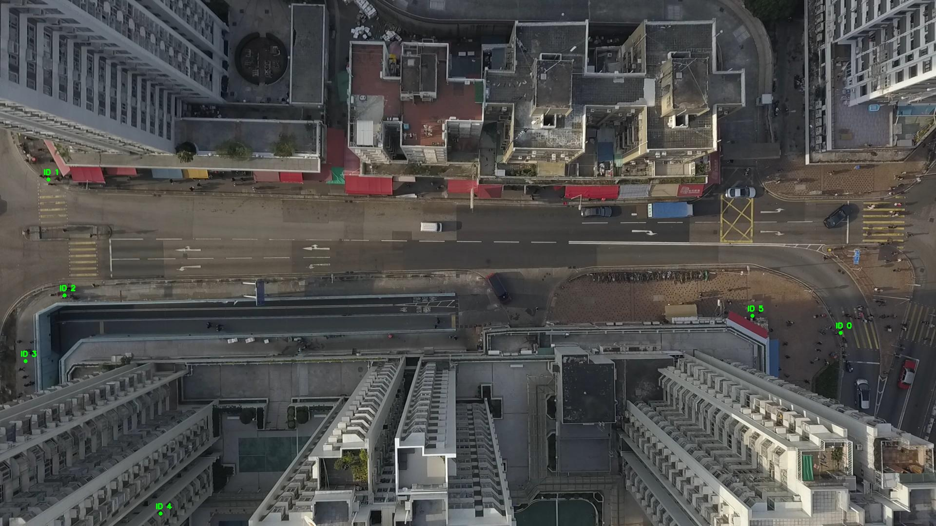

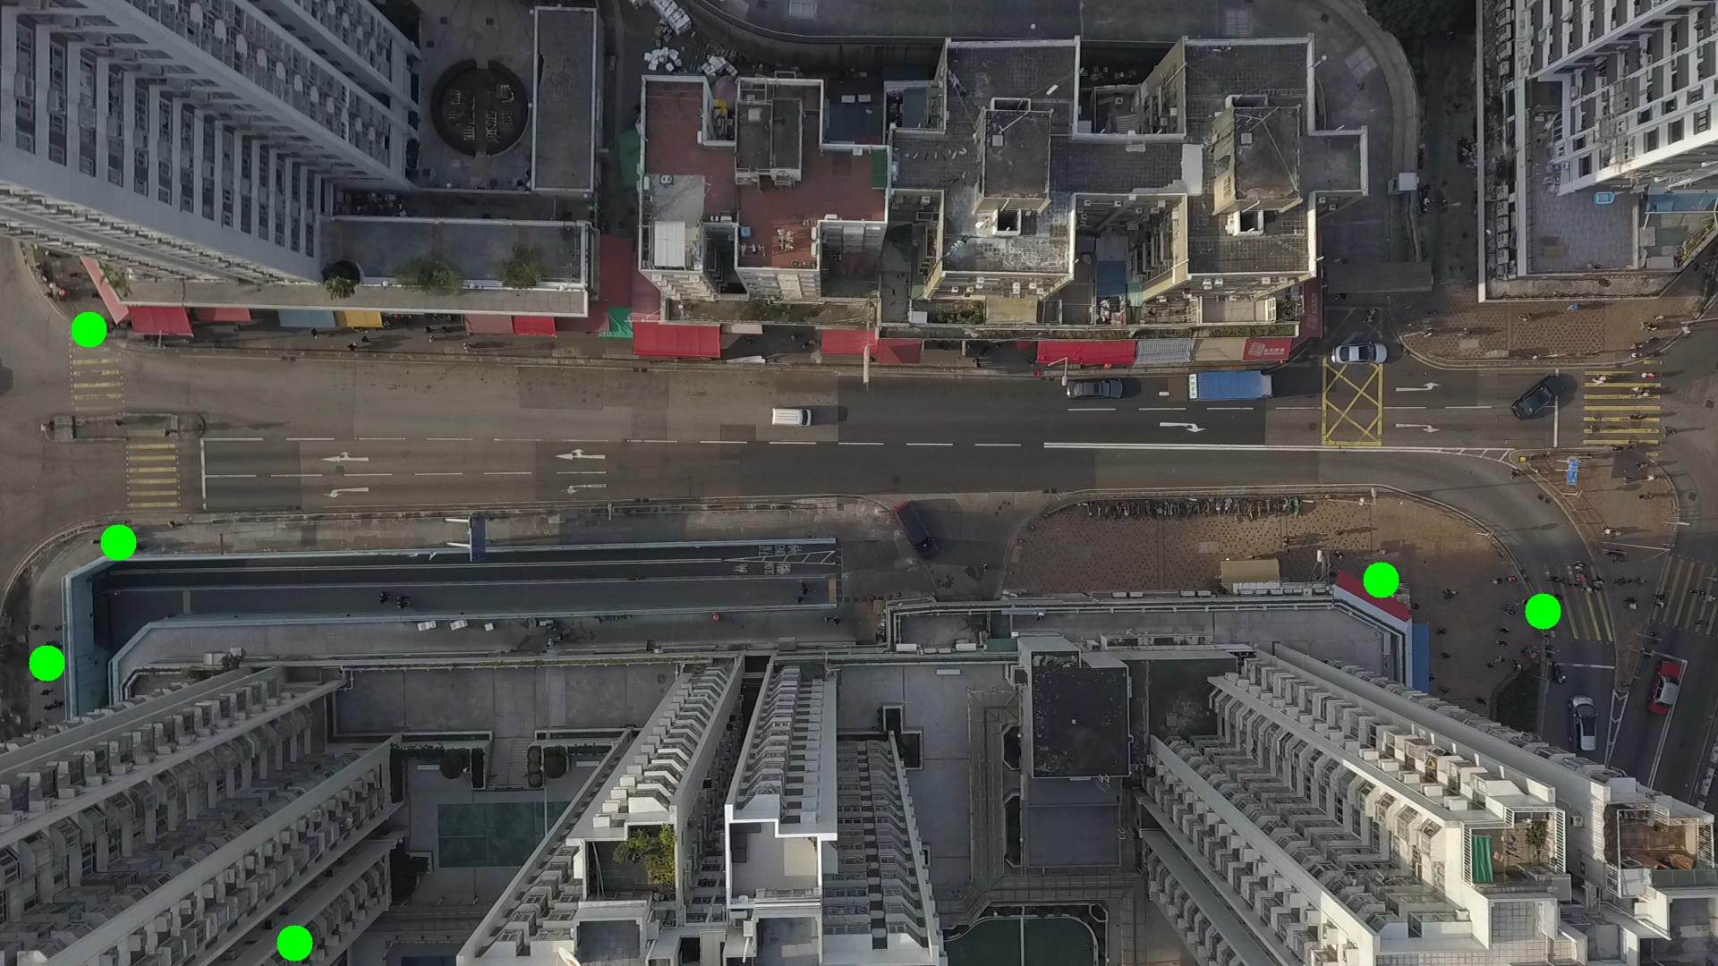

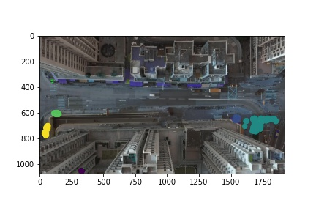

Silhouette metric for img015003.jpg is: 0.7734100996673856

Davies Bouldin metric for img015003.jpg is: 0.17235168115046706

Calinski Harabasz metric for img015003.jpg is: 161345.45250854688

ID 0: (1705, 677)

ID 1: (99, 368)

ID 2: (131, 606)

ID 3: (52, 732)

ID 4: (331, 1054)

ID 5: (1543, 648)

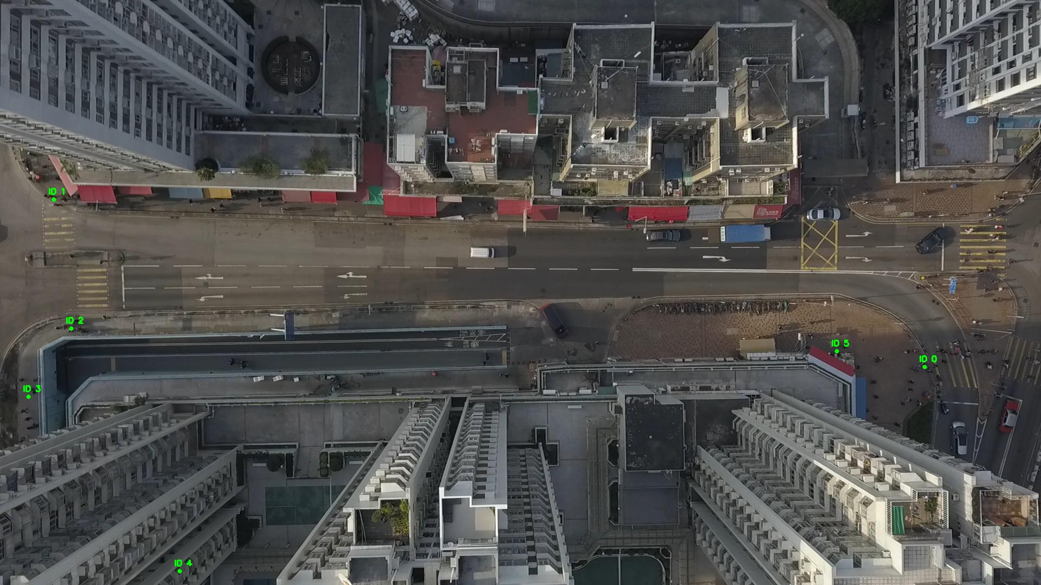

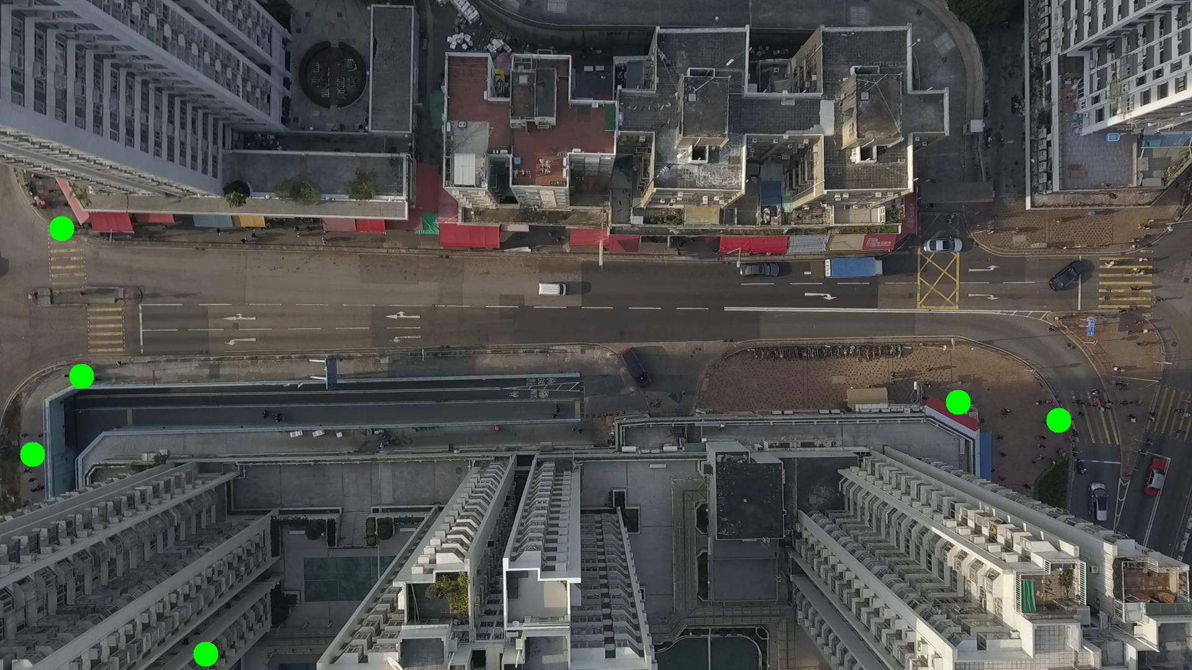

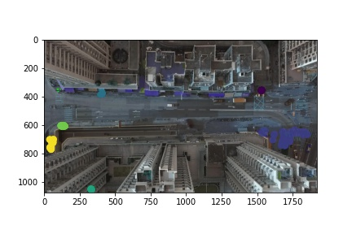

Silhouette metric for img015004.jpg is: 0.7883629389957858

Davies Bouldin metric for img015004.jpg is: 0.1581837848282596

Calinski Harabasz metric for img015004.jpg is: 149078.84865991145

ID 0: (1695, 677)

ID 1: (102, 368)

ID 2: (130, 605)

ID 3: (50, 727)

ID 4: (332, 1054)

ID 5: (1543, 648)

ID 6: (409, 377)

ID 7: (1529, 356)

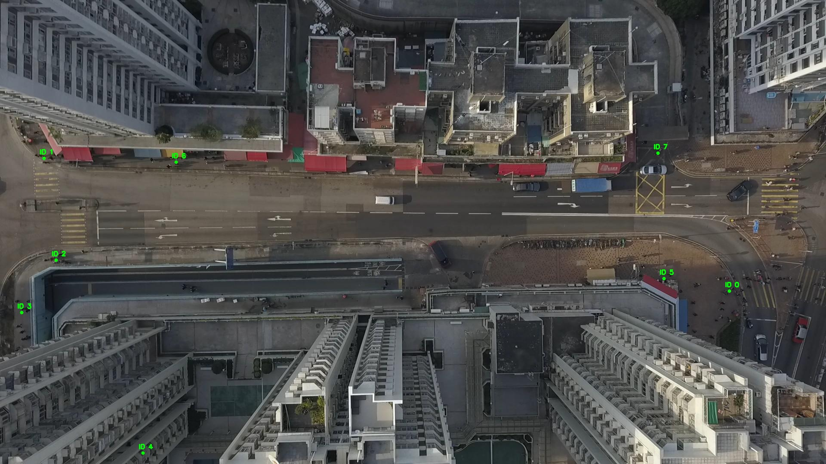

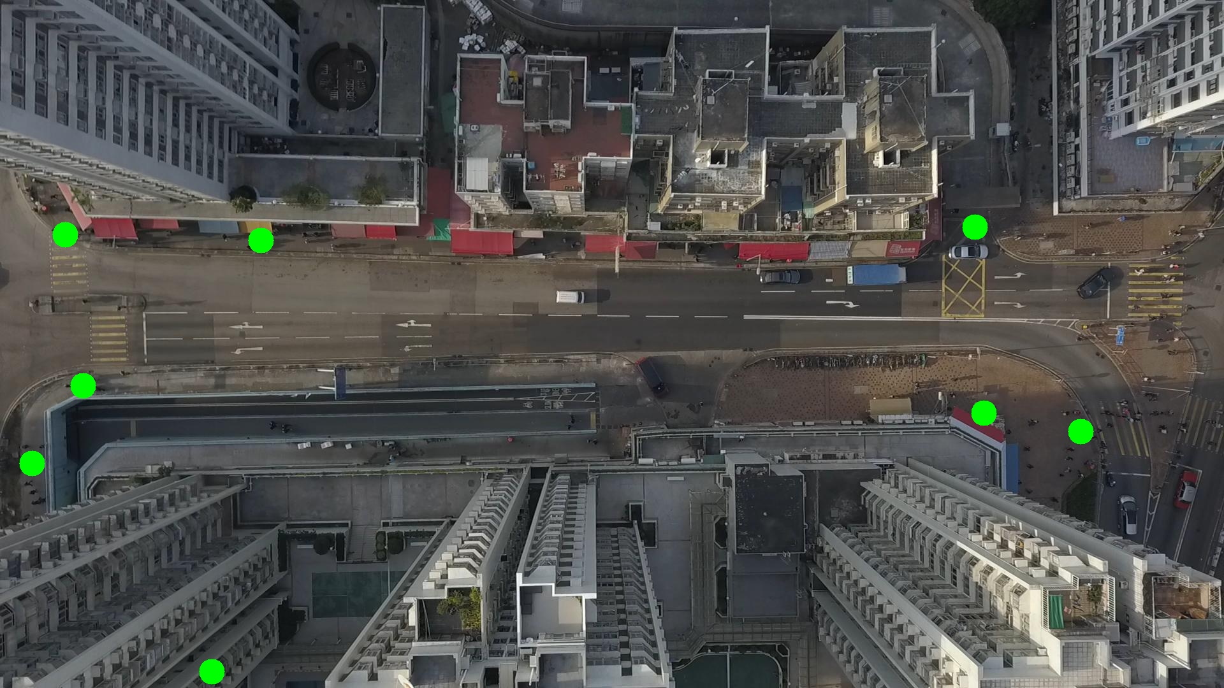

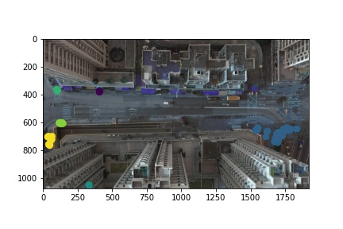

Silhouette metric for img015005.jpg is: 0.7806997229419592

Davies Bouldin metric for img015005.jpg is: 0.16011167480712016

Calinski Harabasz metric for img015005.jpg is: 130518.41275686483

ID 0: (1707, 676)

ID 1: (105, 370)

ID 2: (130, 606)

ID 3: (53, 730)

ID 4: (331, 1053)

ID 5: (1543, 648)

ID 6: (409, 378)

ID 7: (1529, 355)

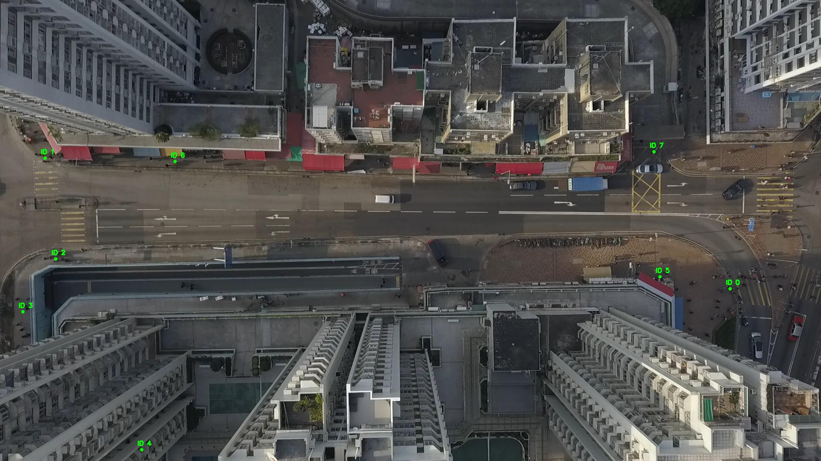

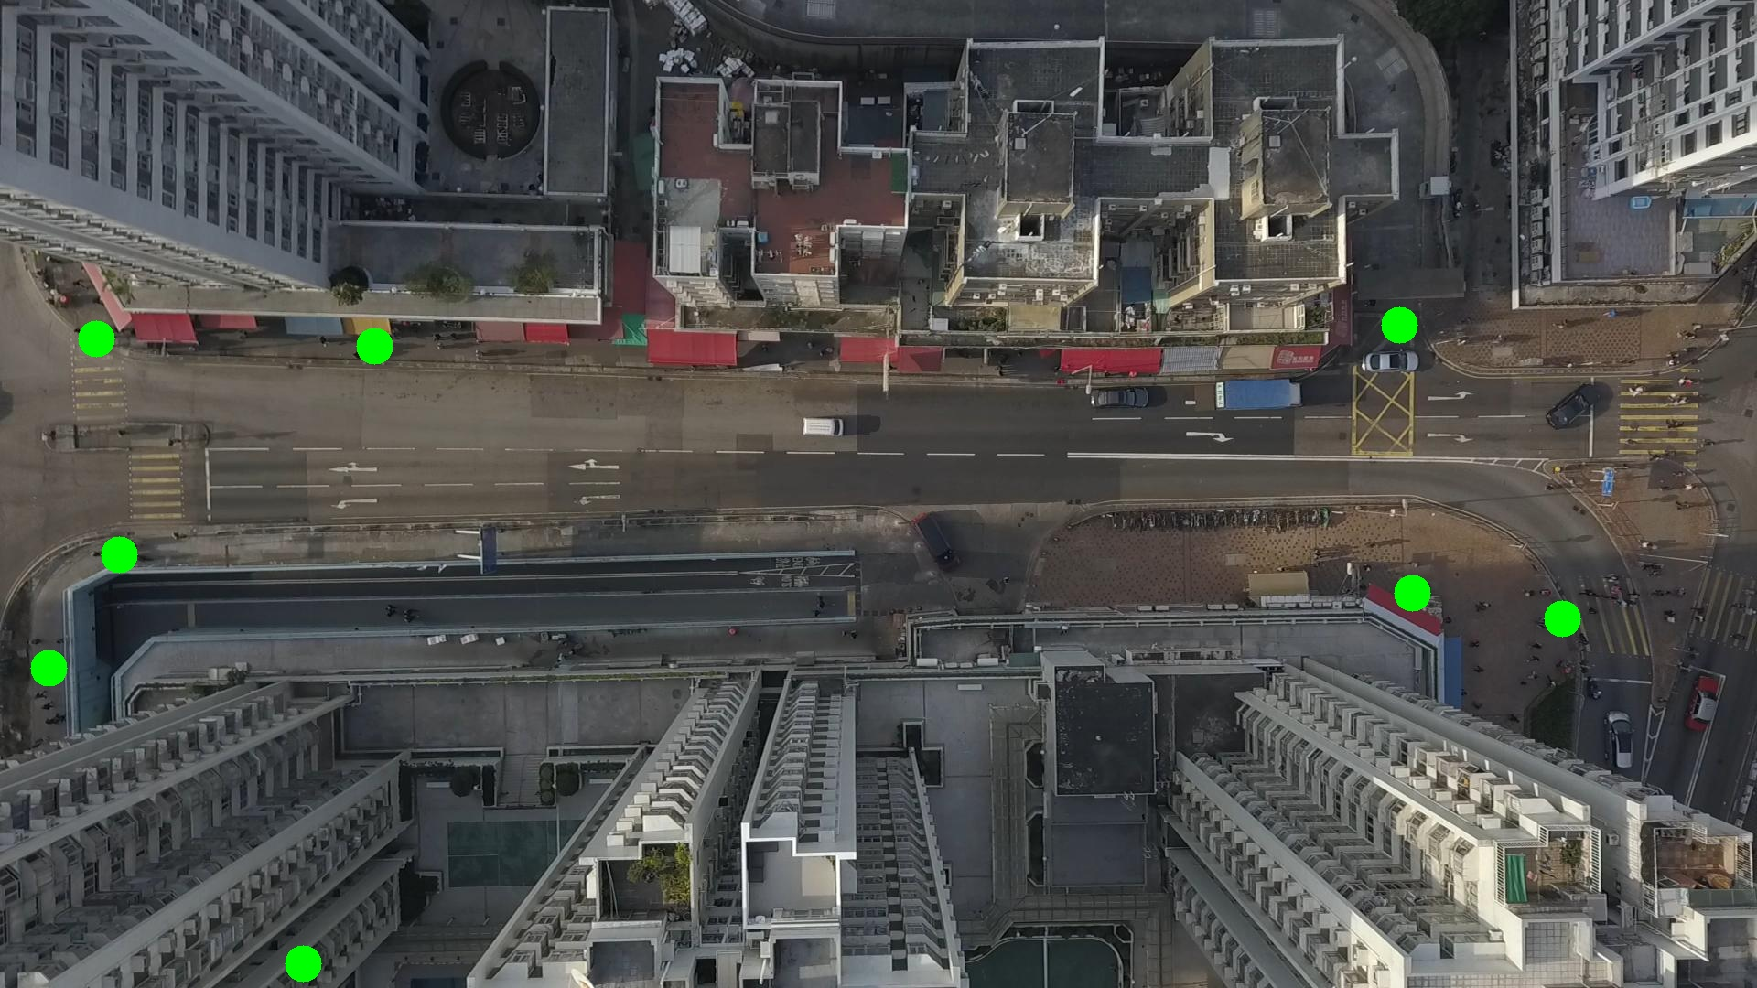

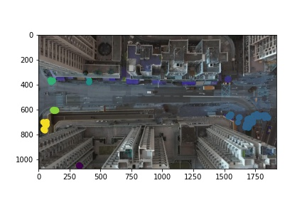

Silhouette metric for img015006.jpg is: 0.7823349548484064

Davies Bouldin metric for img015006.jpg is: 0.1591983571724139

Calinski Harabasz metric for img015006.jpg is: 145676.35781241563

ID 0: (1701, 679)

ID 1: (105, 369)

ID 2: (130, 606)

ID 3: (56, 741)

ID 4: (331, 1053)

ID 5: (1543, 648)

ID 6: (410, 381)

ID 7: (1529, 355)

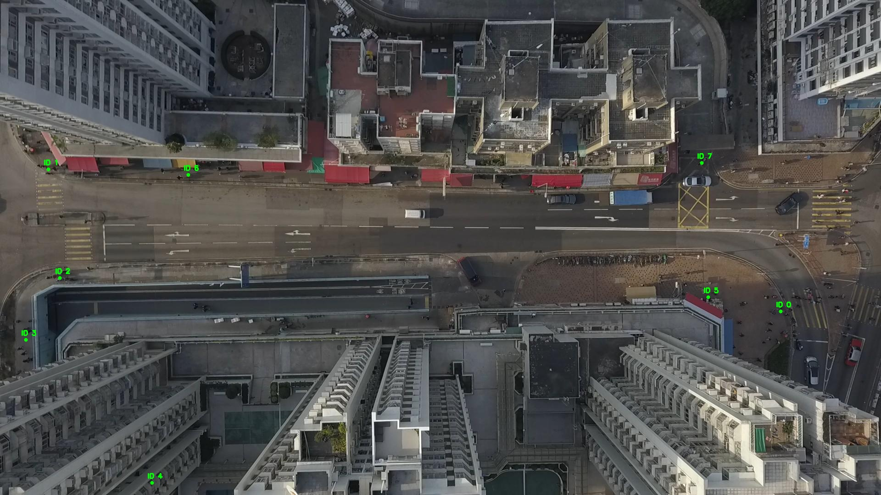

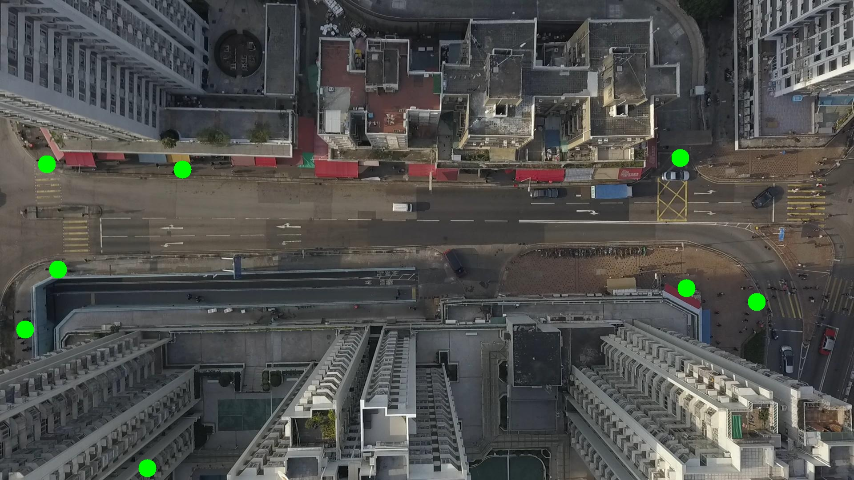

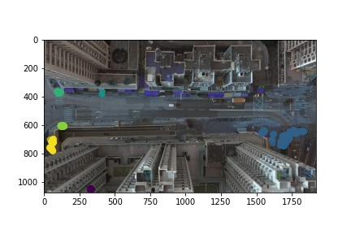

Silhouette metric for img015007.jpg is: 0.7446453601090159

Davies Bouldin metric for img015007.jpg is: 0.19743975082248774

Calinski Harabasz metric for img015007.jpg is: 318980.561983256

ID 0: (1720, 684)

ID 1: (104, 369)

ID 2: (129, 607)

ID 3: (57, 743)

ID 4: (332, 1052)

ID 5: (1545, 651)

ID 6: (410, 379)

ID 7: (1529, 355)

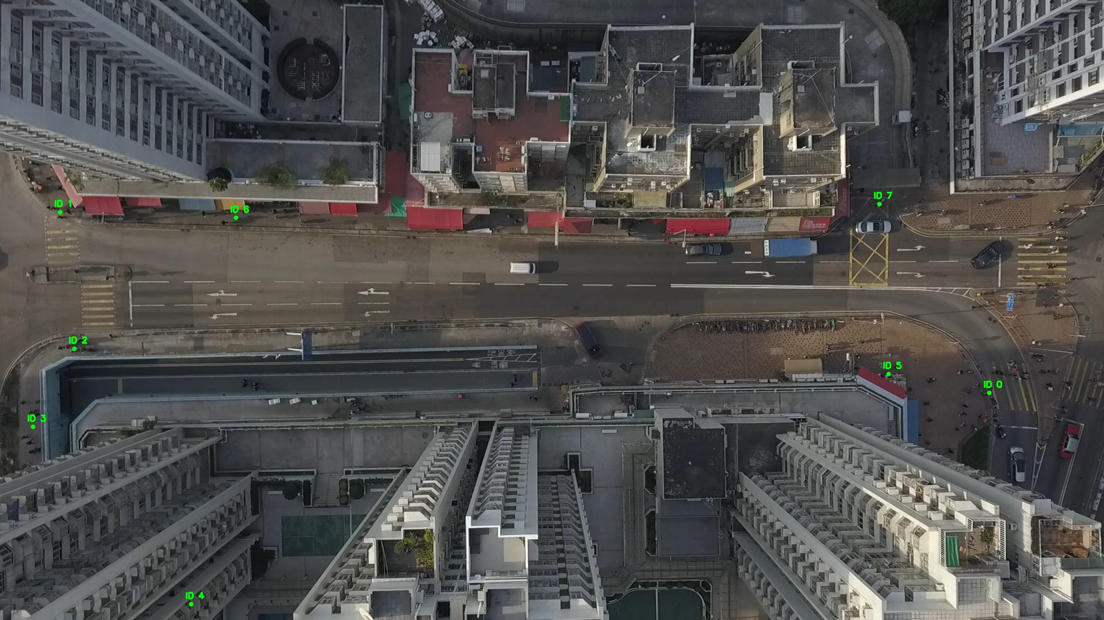

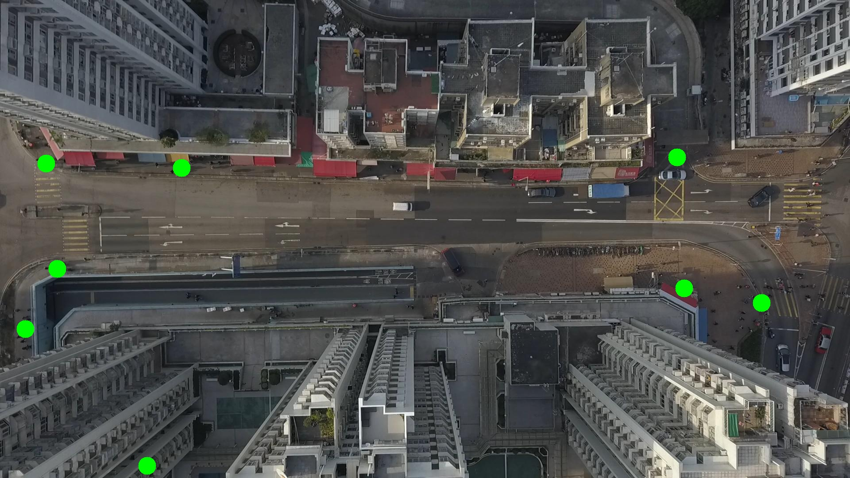

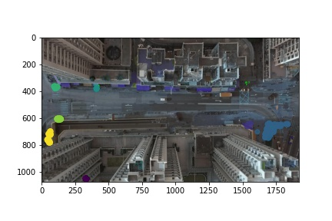

Silhouette metric for img015008.jpg is: 0.7403706954233272

Davies Bouldin metric for img015008.jpg is: 0.19033578546838967

Calinski Harabasz metric for img015008.jpg is: 304924.81027127703

ID 0: (1711, 685)

ID 1: (105, 371)

ID 2: (130, 606)

ID 3: (54, 733)

ID 4: (331, 1052)

ID 5: (1545, 650)

ID 6: (410, 380)

ID 7: (1527, 356)

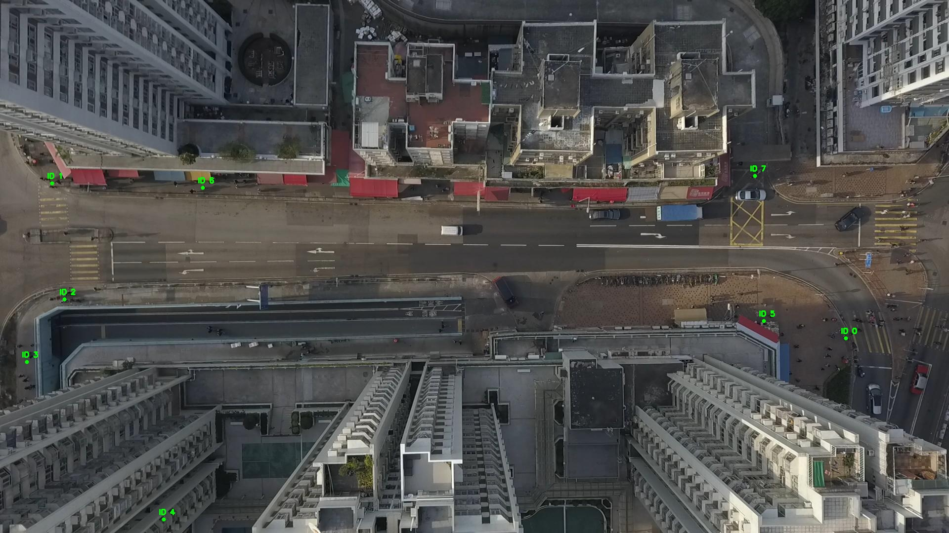

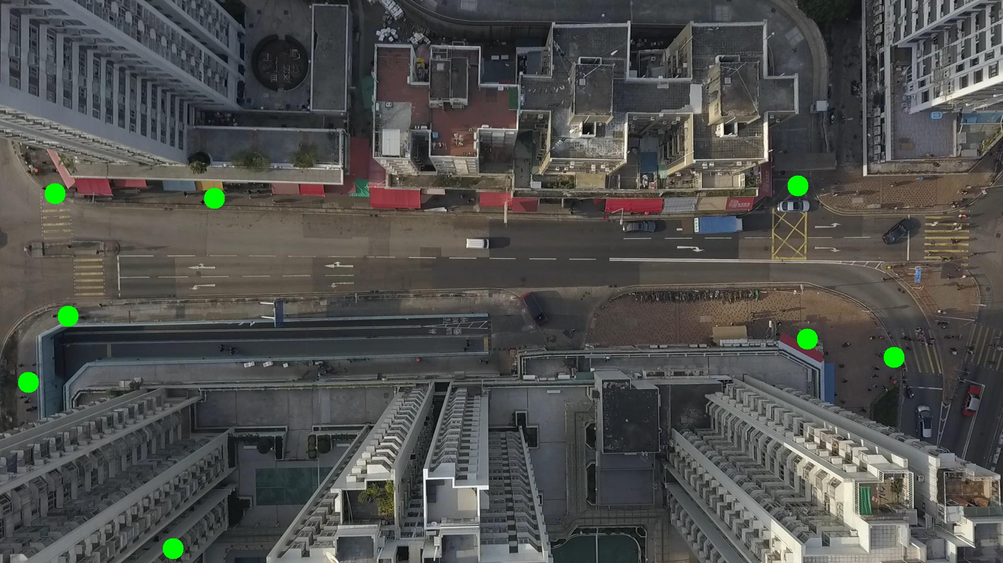

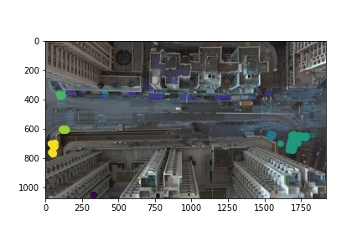

Silhouette metric for img015009.jpg is: 0.713167465411543

Davies Bouldin metric for img015009.jpg is: 0.2028192959525997

Calinski Harabasz metric for img015009.jpg is: 251537.95373415088

ID 0: (1718, 677)

ID 1: (101, 373)

ID 2: (132, 609)

ID 3: (54, 731)

ID 4: (332, 1052)

ID 5: (1544, 651)

ID 6: (417, 376)

ID 7: (1527, 356)

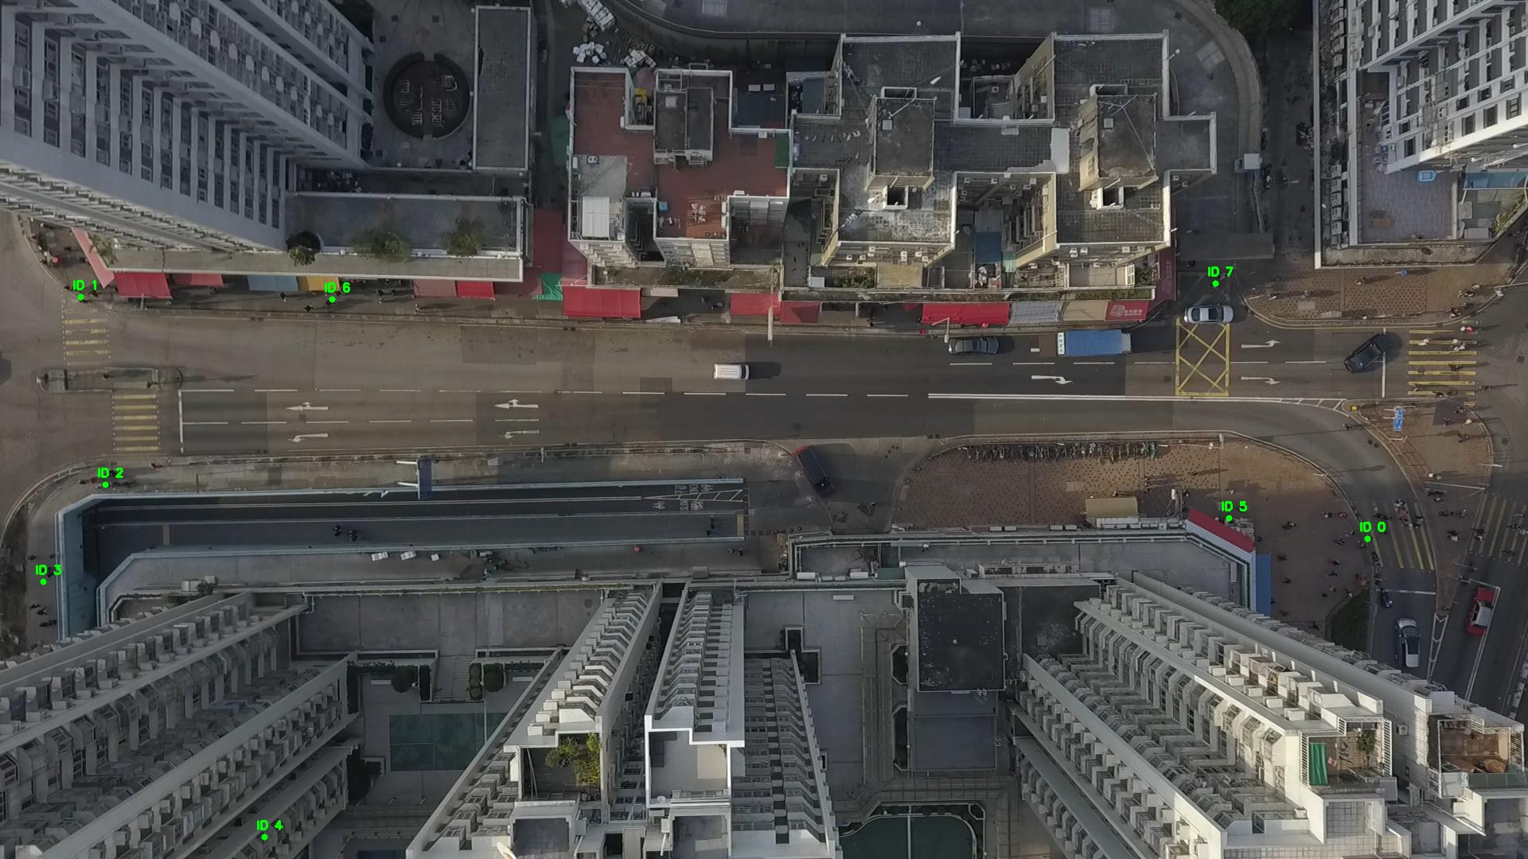

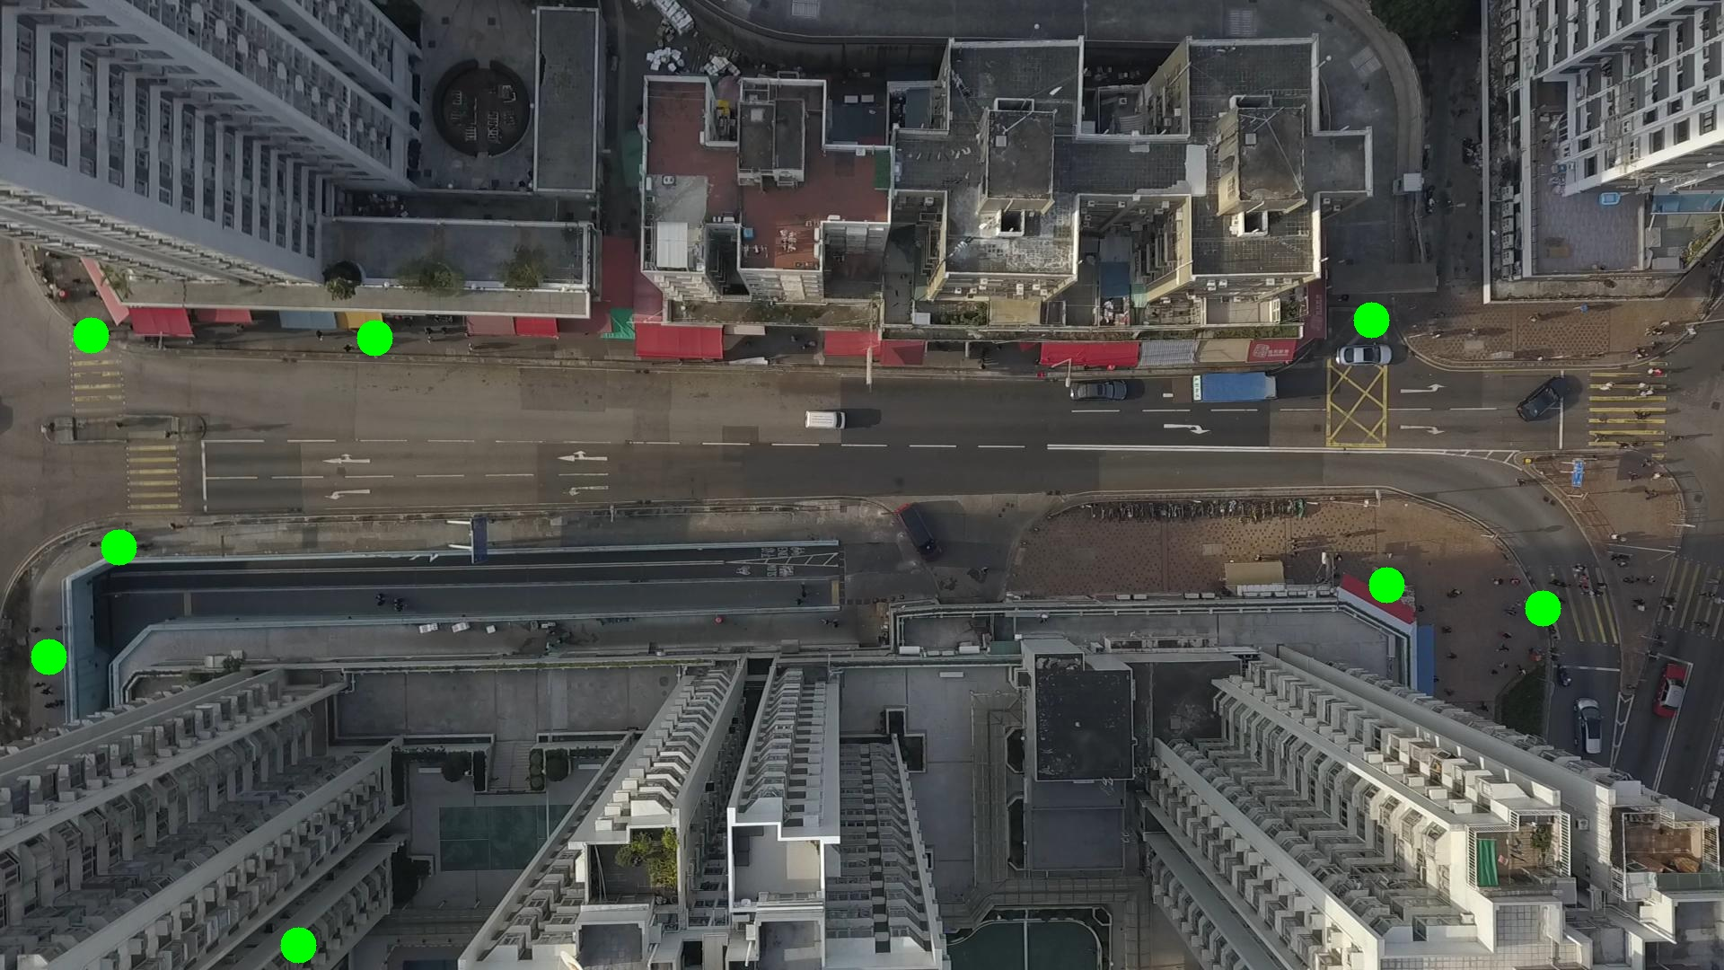

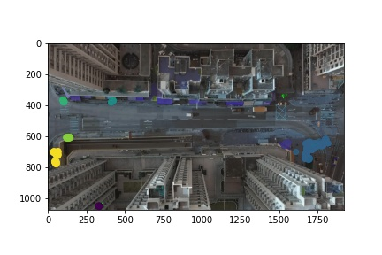

Silhouette metric for img015010.jpg is: 0.8981111433976287

Davies Bouldin metric for img015010.jpg is: 0.12982794083089583

Calinski Harabasz metric for img015010.jpg is: 118973.14862287807

ID 0: (1700, 670)

ID 1: (102, 373)

ID 2: (134, 608)

ID 3: (52, 732)

ID 4: (332, 1052)

ID 5: (1544, 651)

ID 6: (422, 373)

ID 7: (1527, 356)

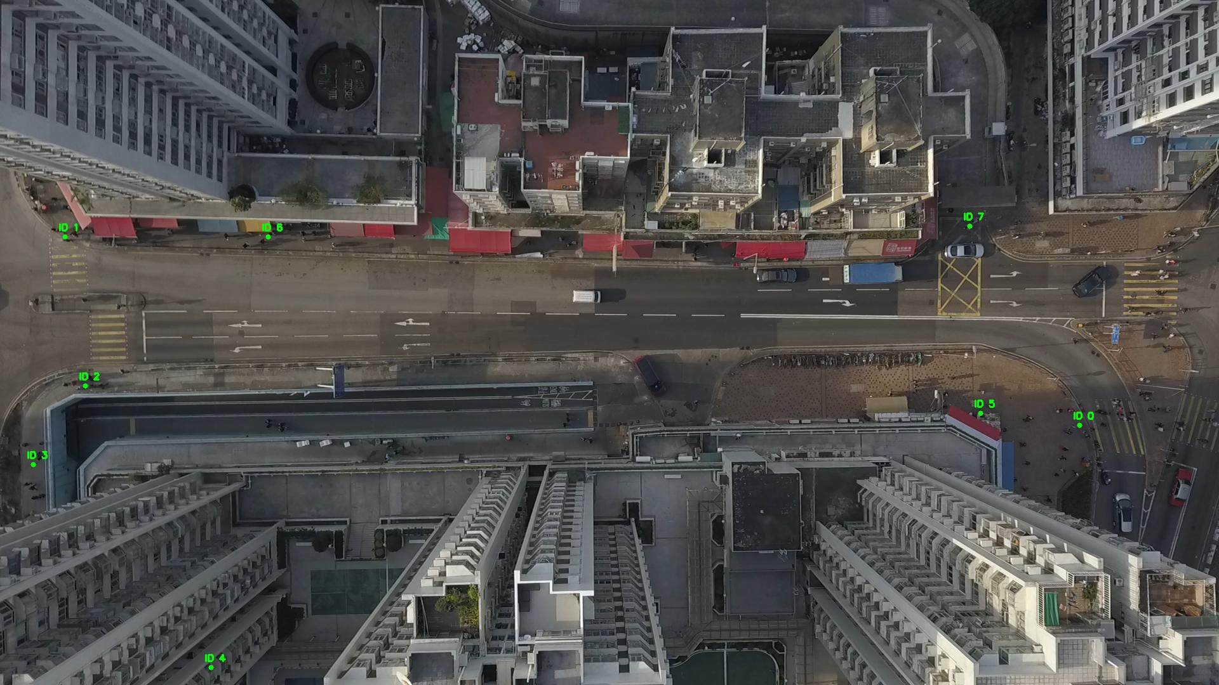

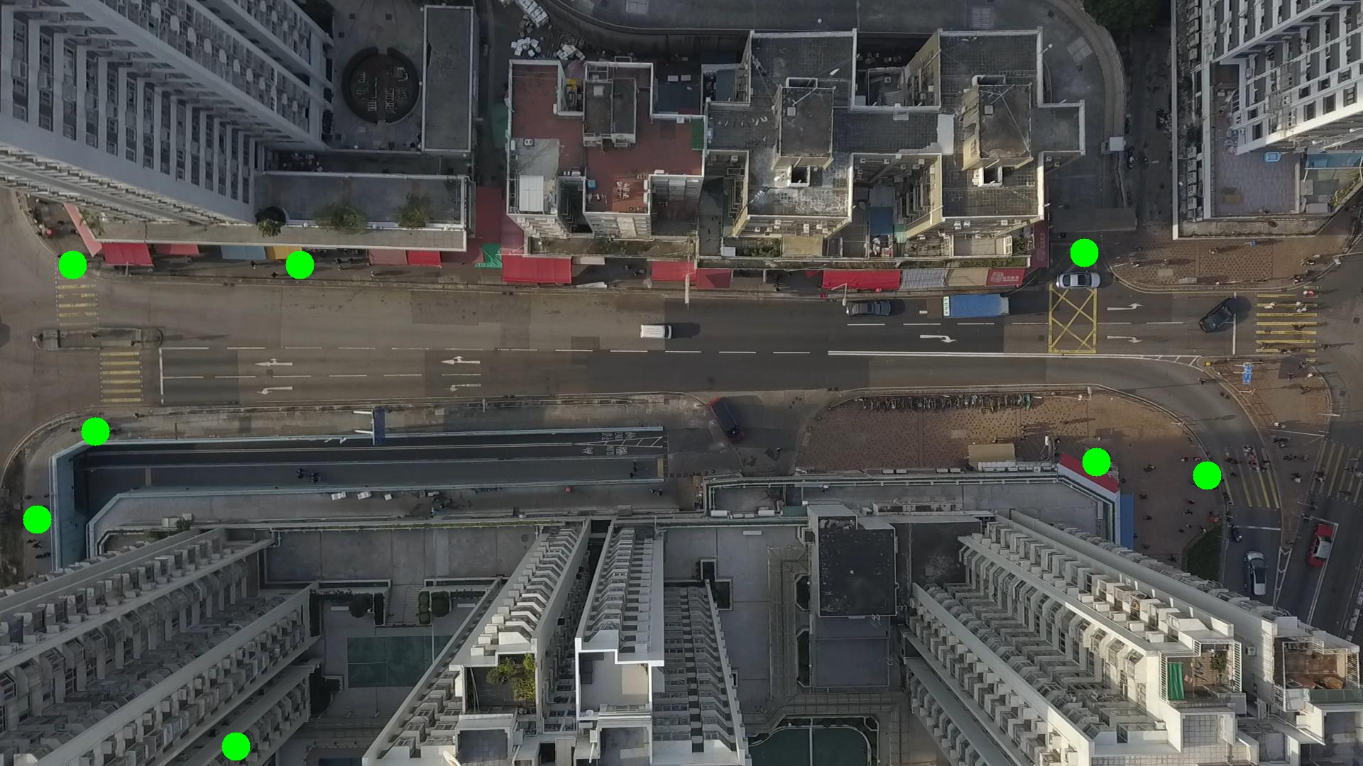

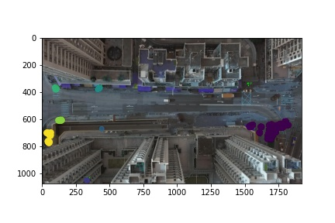

Silhouette metric for img015011.jpg is: 0.9003538621245305

Davies Bouldin metric for img015011.jpg is: 0.1545197238743628

Calinski Harabasz metric for img015011.jpg is: 170278.36887137266

ID 0: (1691, 675)

ID 1: (104, 373)

ID 2: (133, 608)

ID 3: (50, 735)

ID 4: (332, 1052)

ID 5: (1544, 651)

ID 6: (425, 371)

ID 7: (1527, 356)

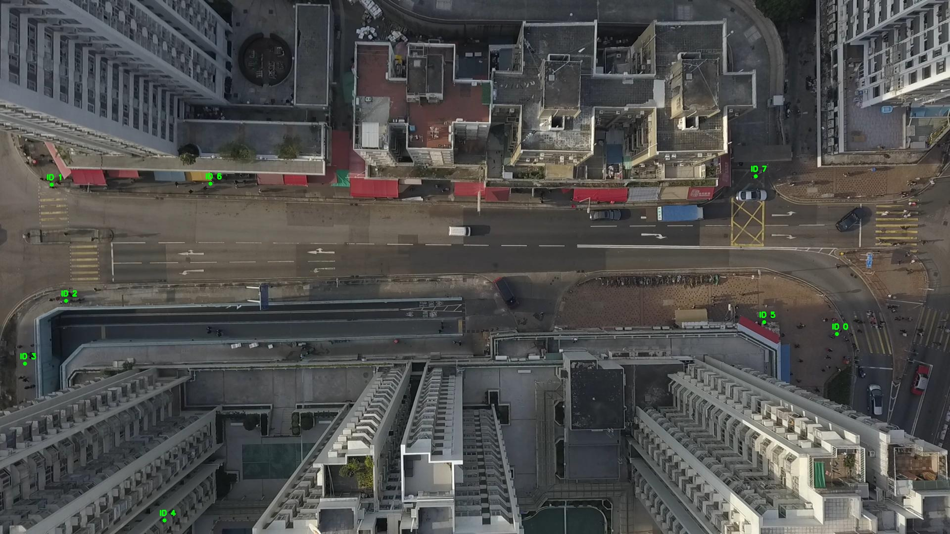

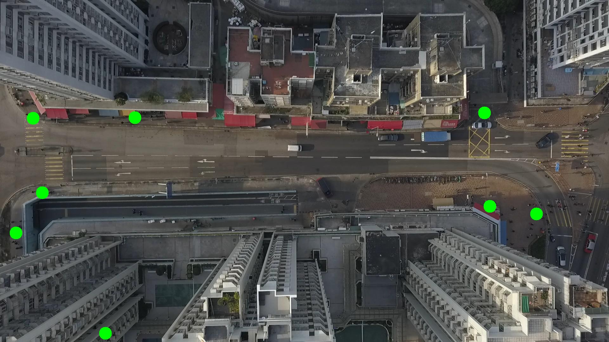

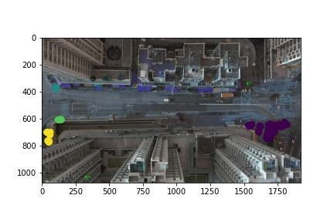

Silhouette metric for img015012.jpg is: 0.906179843234751

Davies Bouldin metric for img015012.jpg is: 0.13448331348016543

Calinski Harabasz metric for img015012.jpg is: 102958.71619088168

ID 0: (1685, 676)

ID 1: (101, 372)

ID 2: (137, 607)

ID 3: (47, 742)

ID 4: (331, 1052)

ID 5: (1544, 651)

ID 6: (426, 371)

ID 7: (1527, 356)

